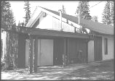ST. JOSEPH’S PARISH
Vanderhoof, BC
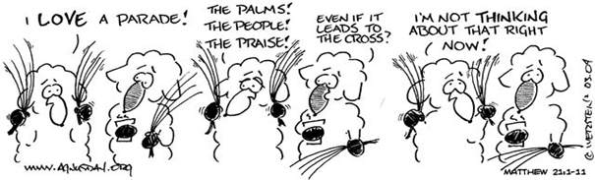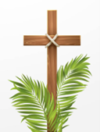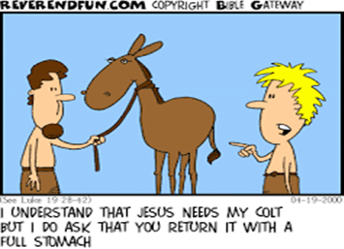



PRAYER REQUESTS: For Brenda Antoine, Jason Aritolla, Mackie Basil, Julio Bonilla jr., Cooper Cursley, Evelyn Embree, Ronald Gilmore, Brent Gray, Ellen Haynes, Patrick Irving, Lisa Ketlo, Halli & Hunter Krawczyk, George LaBrash, Jennifer Lock, Wanda Miller, Della Morin, Eunice Nash, Virginia Power, Dorothy Ranck, Ian Scott, Madeline Scott, Vanessa Stewart, Gerry Theissen, Mike VanDusen, Art Wiens and for all who are ill or in need of God’s healing grace.
Remedy Rebuild / SaMaArtStudio- Magdalena Saito Local herbalist & apothecary *faith resources* art prints* Catholic content 250-524-0333 saitomaggie@gmail.com
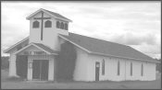HOLY TRINITY CHURCH MISSION Saik’uz First Nation, BC
Palm Sunday
Year A
March 29, 2026
“Hosanna in the highest! Blessed are you, who have come in your abundant mercy!”

PASTOR: Rev. Pier Pandolfo  1-250-614-3220  Parish Phone: (250) 567-9151  Parish Fax: (250) 567-9115  2994 Burrard Ave.  P.O. Box 1429  Vanderhoof B.C V0J 3A0  E-mail: stjosephsp93@gmail.com  Website: stjosephsvanderhoof.ca  EUCHARIST  Saturday St. Joseph……...5:00 p.m.  Sunday St. Joseph……….9:30 a.m.  Sunday Holy Trinity…..12:00 noon  Tues & Thurs……………6:30 p.m.  Wed & Fri……………….9:00 a.m.  RECONCILIATION  By appointment.  BAPTISM  Contact Father Pier for more  information.  MATRIMONY  Please contact Father Pier for an appointment at least six months | Ushering in the holiest week of the year, Palm Sunday sheds light on our life’s journey. Jesus rode triumphantly into Jerusalem, to the wild acclaim of the cheering crowd. Yet he did so on a humble donkey, leading the way into his kingdom, and knowing that this was just the overture to a week of Passion.  We wave our palm branches and process into the church, joyously singing praises. Yet almost immediately, we plunge from glory into unimaginable grief with a description of the Suffering Servant, the psalm of abandonment used by Jesus on the Cross, and the reading of his Passion. Our human nature recoils: this is not the way our Saviour should be treated. This is not the way our life should go.  And yet it does. One year, I bask in light and hope, and the next sees my dreams shredded at my feet. As Jesus cried out, Father, why have you abandoned me?, his heart did not waver from both his trust in God and his passion to save us by conquering death through his own death and resurrection.  Whether at the seeming pinnacle or nadir of our life, our eyes and hearts must be rivetted to our Redeemer, who is even now leading us into eternal life. Let us not take our eyes off him!  c Living with Christ/Novalis/ Bayard Presse Canada. Used with Permission

From ‘Hosanna’ to ‘Crucify Him.’ The word ‘Hosanna’ is used to express our joy and adoration for Jesus and the work of healing and teaching that he did. These words change to ‘Crucify Him’ as we take the part of the crowd at the trial of Jesus.
Homework: every new baby you see, pray “Lord, let me bring hope and transformation.”

He descended into Hell. (Pope Benedict reflection) The Eastern Church’s picture of Easter has taken a different path from that of the Western world and the images which are familiar to us. She does not show the Lord having burst from the grave, suspended in a brilliant, divine glory above the world, as in Grünewald’s impressive and masterful painting. Since Scripture itself does not portray the Resurrection event, Eastern believers too refrained from depicting it. The icon, by contrast, represents as it were the mysterious inner dimension of the event of Easter which is indicated by a few words of Scripture and which we profess in the Creed when we say, “He descended into hell”. In the perspective of the icon, this is an affirmation concerning Jesus’ victory. The icon shows him having shattered the bolt of this world, having torn its gates from their hinges. It depicts him as the “stronger man” who has opened and penetrated the domain of the “strong man”. It portrays him as the Victor, having burst through the supposedly impregnable fortress of death, such that death is now no longer a place of no return; its doors lie open. Christ, in the aura of his wounded love, stands in this doorway, addresses the still somnolent Adam and takes him by the hand to lead him forth. The liturgy of Holy Saturday circles around this event.

Holy Thursday: With the tabernacle empty, we gather to celebrate the gifts of the Eucharist, the Priesthood, and the call to serve (wash the feet of one another).

Good Friday. The service begins with a procession in silence. Our hearts are being prepared to hear and to receive the story of our Savior’s passion. It is a day of fasting and abstinence from meat. Although permissible, it is not necessary to receive communion at the service.

Easter Vigil. This is the great night of our faith. As the people of Isreal were liberated from slavery in Egypt, so we hear the stories of how God liberates us. We renew our baptismal promises and commit to living lives that are free from sin, with the help of God’s grace.

Easter Sunday. We celebrate that Christ is victorious over death.

ALPHA7: 8 participants discussed the question How God Guides us; the following sources were
identified: scripture, Holy Spirit prayer, saintly people, our common sense, and coincidental signs;
pray for the participants as they will be on retreat Friday and Saturday; next week: How do we resist evil?
LHC Life Healing Choices: October 2026; pray always for those with addictions.
Transformed lives, transforming community: mission statement for evangelization;
Intimate encounter with God through an open heart: mission statement for prayer;

PARISH ACTIVITIES: April 02-April 05 Holy Triduum
PARISH ACTIVITIES: April 03 6:30 Friday: Stations of the Cross individually

QUIET PARISH HEROS: those who organized the Rice Dinner

CWL ROSARY INITIATIVE
Have old or broken rosaries?
If you have loose beads, broken pieces, or parts of rosaries you’d like to donate, please give them to the CWL for repurposing.
If you have a rosary, you’d like repaired, connect with Connie Wallace, our local rosary expert.
Donated pieces may be used to repair rosaries, create new ones, or support this ongoing project.
Thank you for helping keep these sacred items in use

CWL Prayer Cards Initiative
Prayer cards are available at the back of the foyer by the CWL box.
Write your prayer intention and place the card in the box.
Members of the CWL and/or the Prayer Circle will pray for these intentions.
If you would like to take part in this prayer initiative, please connect with your CWL
2025 DIOCESAN ANNUAL APPEAL – CALLED TOGETHER
Parish Goal: $13,952 Actual to Date: $18,772

Rachel’s Vineyard – Serving the North
OUR NEW WEBSITE IS NOW IN OPERATION! www.rachelsvineyardpg.ca SPRING WEEKEND RETREAT FOR 2026: May 22 – 24, registrations now being accepted. For Further information on this Healing Ministry, please refer to our website. Confidentiality Assured. THANK YOU TO ALL THOSE IN OUR DIOCESE WHO HAVE SUPPORTED OUR WORK IN 2025!
Check out the diocesan website for more information on happenings in the diocese. www.pgdiocese.bc.ca

